Player vs Player
Open Kingdom
[LTZ] Badder

WHAT DOES THE KINGDOM OPENING MEAN?

Right now our Kingdom is closed or protected, similar to how a Shield of Peace protects cities. When the Kingdom opens, it means that we will have access to other Kingdoms and they will have access to us.

As a result, we will be able to participate in several new tournaments.

Ayrin players from our Kingdom will also have the opportunity to attack players in other kingdoms for CP, resources and gold ingots to bring back to our Kingdom. Of course, we can also be scouted and attacked by players from other Kingdoms at any time, so *it is very important now to get into the habit of having a no-value city.*

WHAT NEW TOURNAMENTS?

The biggest, most important ones for your clans will be Trials of Olympus, Dark Omens, Clash of Kingdoms, and Trade Routes (mercenary exchanges).

However, there are many other mini tournaments for personal rewards (Wargames, Silver Rush, Gold Rush) where getting a place on the leaderboard is possible with an open Kingdom.

I DONT LIKE THE IDEA OF BEING ATTACKED ALL THE TIME

It's very easy to prevent attacks; simply keep your city from having any value to outsiders. Keep your resources below the protected limits of your warehouse, send your troops to the fort when going offline, and pay your taxes!

Our newly opened Kingdom will be a source of curiosity for the first few weeks, so expect lots of scouting. However, if we keep our cities valueless to attackers, they will slowly stop visiting.

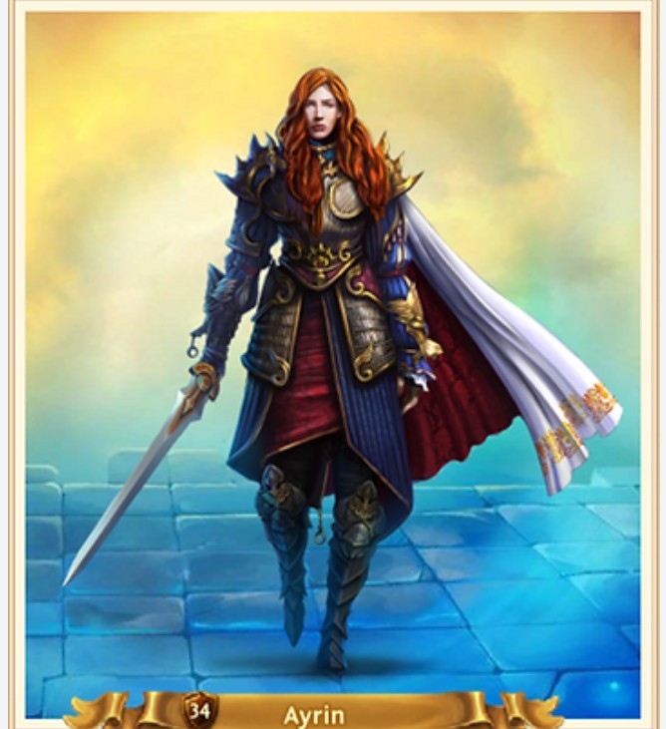
WHAT'S SO SPECIAL ABOUT AYRIN?

Ayrin is the only Hero who can access other Kingdoms at any time you desire. Players using other heroes have access restricted to certain tournaments and can only travel using special portals.

Ayrin is best for PvP growth-focused players as she allows you to prioritize raiding other Kingdoms for silver, RSS, and gold ingots.

Player vs Player
IKFPA Agreement
[LTZ] Badder

Updated: January 12th, 2026

These are the rules our Kingdom has agreed to play by when visiting any of the following Kingdoms, and in general, are simply good principles for visiting any Kingdom. THIS IS NOT A NON-AGGRESSION PACT!

84, 87, 114, 115, 116, 120, 121,124, 129, 130, 135, 141, 143, 144, 145, 146, 149, 150, 154, 160, 161, 162, 164, 165, 171, 172, 173, 175, 176, 178, 179, 180, 181, 182, 183, 184, 186, 188, 190, 192, 193, 194, 195, 196, 197, 198, 199, 201,202, 203,204, 205, 207, 212, 213, 216, 217, 218, 219, 222, 223, 225, 226, 227, 229, 230, 231, 232, 233, 234,235,237, 238,239, 240, 241, 242, 243, 244, 245, 246, 247, 248, 249, 252, 253, 254, 255. 256, 257, 258, 259, 260, 261, 263,264,265,266, 267, 268, 269, 270, 272, 273, 274,275, 277, 281, 282, 283,1000, 1002, 1005, 1006, 1008

Summary:

-No hate speech
-No attacks: clan buildings, memorial portals, or players under 100K might
-ALL RSS tiles protected from attacks except during PvP events: CoT, KvK, War Tools, Gold / Silver Rush, War Games, Lava Trials, (does NOT include Ruthless Slaughter).
-Fort attacks on other kingdoms declared immediate outlaw status per kingdom ROE
-Compensation < 48 hrs

Events & Epic Monsters
TRADE ROUTES (MERCENARY EXCHANGES)
[LTZ] Badder

During this tournament, you will be able to send your Captains to Exchanges in other Kingdoms to buy mercenaries in exchange for Silver.

It is not possible to trade on the exchanges in your own Kingdom. Your city must have a Caravan building to participate. The maximum march time to an exchange is two hours unless you have Ayrin as your hero. Finding exchanges is the toughest part of the tournament. There are exchange chats where players share coordinates, but you may also have success tracing red lines on the world map as hundreds of players flock to the exchange.

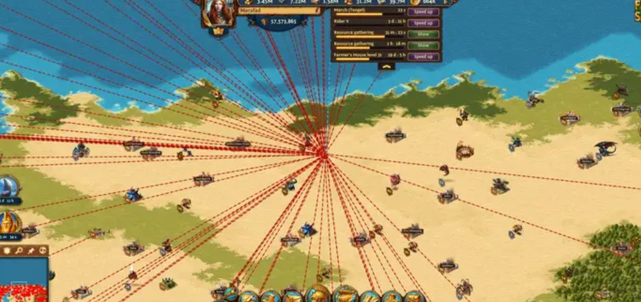

Finding exchanges is the toughest part of the tournament. There are exchange chats where players share coordinates, but you may also have success tracing red lines on the world map as hundreds of players flock to the exchange.

Each Exchange is slightly different for each player, depending on your completed research. Exchanges that have sold out disappear from the Kingdom Map.

Send your fastest Captain (Tengel with the Drum artifact) to the Exchange. The silver is deducted as soon as the Captain starts the march.
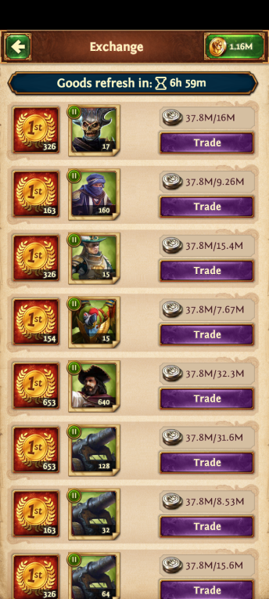
The new troops are hired at the moment the Captain arrives at the exchange IF they are still available. If your purchase is successful, a notice will appear in your Journal, showing the number of Mercenaries acquired, and the Captain automatically returns to the City with the new mercenaries. If you do not make it to the exchange before it sells out, your Silver will be returned to the City when the Captain returns.

